**Database**

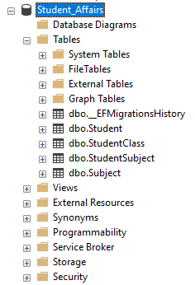

|  |
| --- |
| **Students** |
| Student_ID |
| Student_Name |
| student_Address |
| Student_BithDate |
| Student_EmailAddress |
| **StudentSubject** |
| ID |
| Student_ID |
| Subject_ID |
| **StudentClass** |
| StudentClass_ID |
| StudentClass_Name |
| **Subject** |
| Subject_ID |
| Subject_Name |
| Subject_Description |

|  |  |
| --- | --- |
|  |  |

**Database ERD with its Schema**:

Schema is dbo default schema.

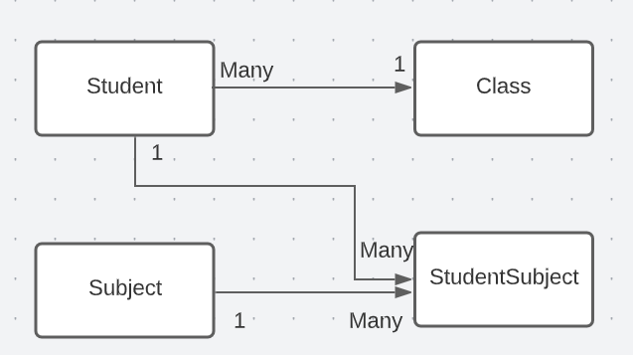

**Web Project**

**Create web project:**

* A new solution “**Student_Affairs**” and a Students Project on MS Visual Studio

**Project Structure:**

The solution contains 4 projects:

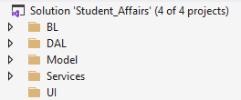

1. ***Model Project:***

***The model project contains:***

* Database models
* Custom models
* Migration scripts
* Mapping profile

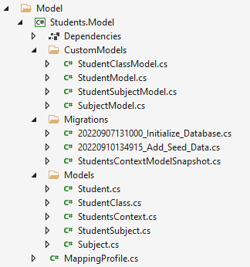

1. ***Data Access Layer Project (DAL)***

***The DAL project contains:***

* Repositories(Generic and custom)
* The repositories interfaces

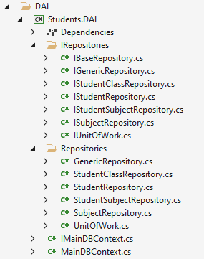

1. ***Business Layer Project (BL)***

***The BL contains:***

* Managers
* Managers interface
* Manager factories if any
* Manager factories interfaces

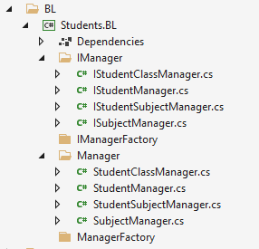

1. ***Services Project***

***The services project contains***

* all APIs and OData controllers to be used as the end points for the application
* The startup with all the registered services and middle-wares
* Service extension class to handle methods

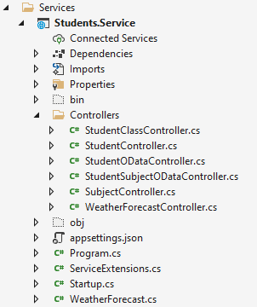

1. ***User Interface Project (UI)***

***The ui project has the angular application for the frontend which contains:***

* Models
* Controllers
* Services

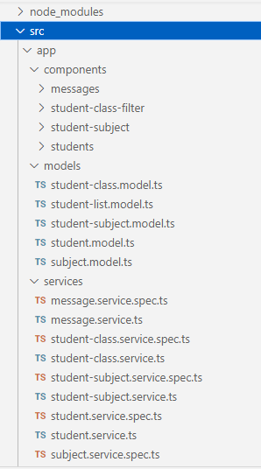

***Students Module***

* Create a web form to add a new student with all details fields

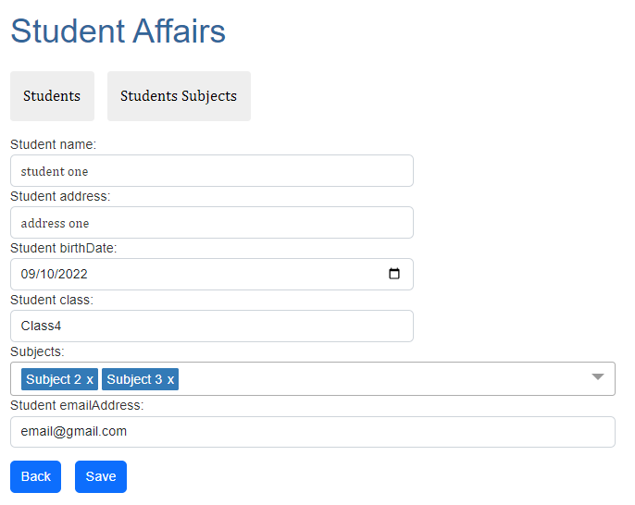

* Make all available validation

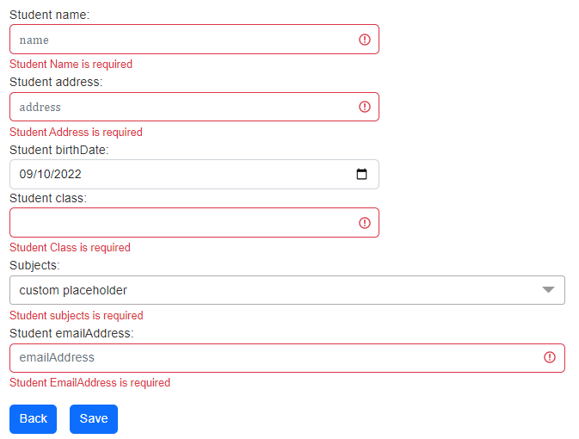

* Create a web form to list all students with columns (*Student* Name – *Student* Address) with paging (**10**) students per each page - **sorting by Student Name**

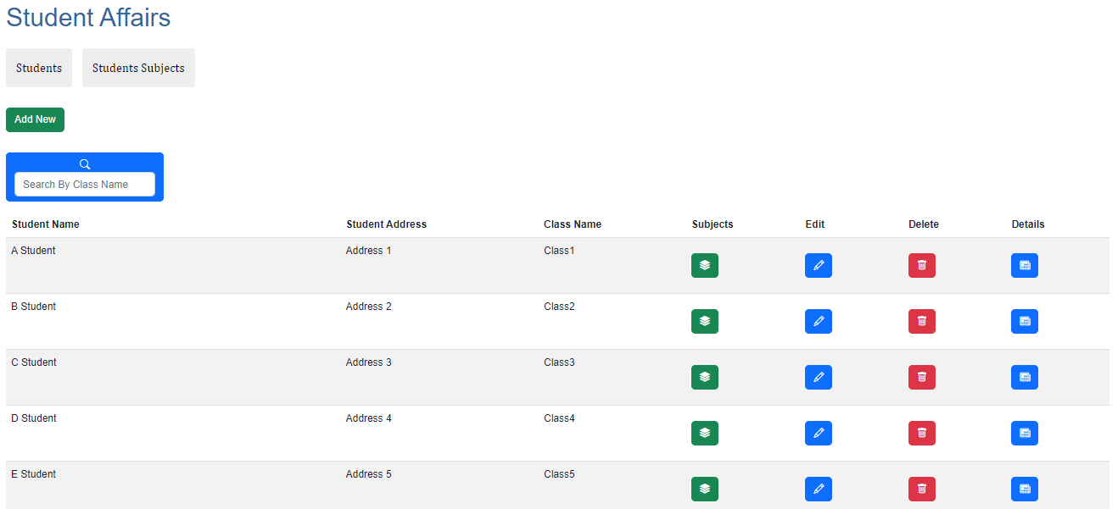

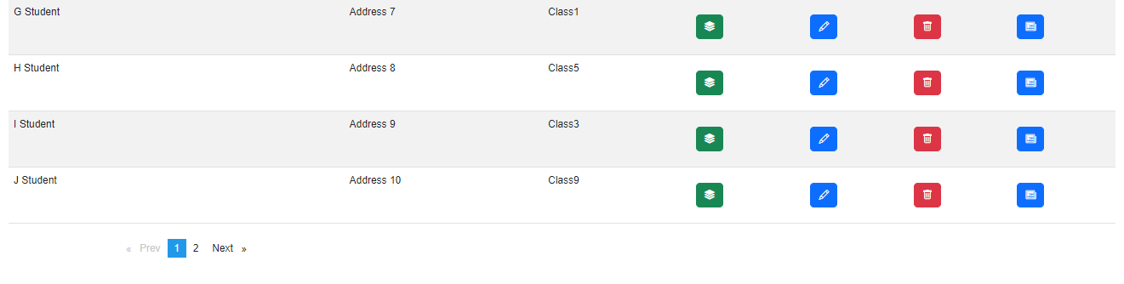

* Enable filter for students listing by his/her Class Name

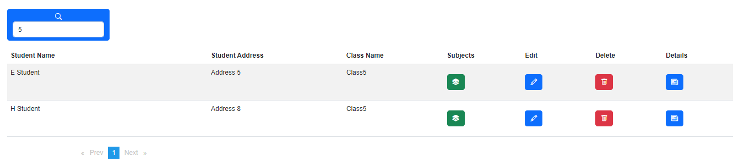

* Enable Manage students (Edit - Delete) feature in the listing students page

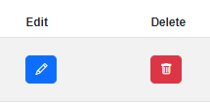

*Students - Subjects Component*

* Manage Subjects for each students
  + On the Same Edit Student page, Create a Student Subjects Component to **Add** & **Remove** multiple subjects for the student.

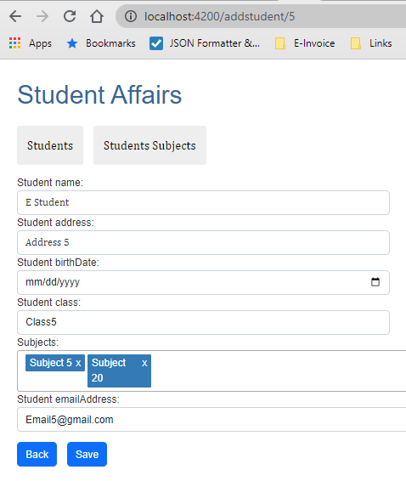

* + *Listing of Subjects in Student Details Pag.*

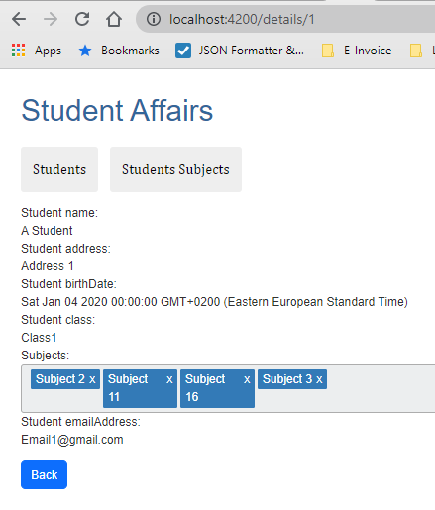

***Students - Subjects Listing***

* Listing Student and Subjects
  + Create a list of Student and subject **order by Student Name**

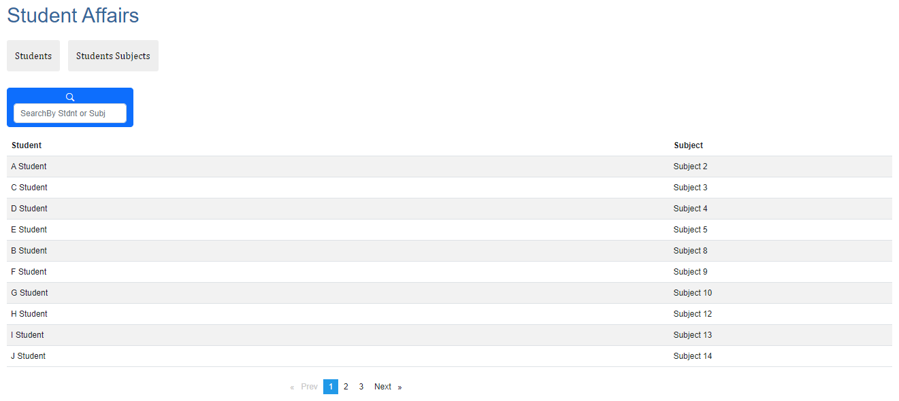

* + Filter by Subject Name and Students Name , enable paging (**10**) per each page

